# The Dungeon Football

# Game Design Document

1. Title Page
   1. Game Name – Perhaps also add a subtitle or high concept sentence.
   2. Version
   3. Developer
2. Game Overview
   1. Game Concept
   2. Genre
   3. Target Audience
   4. Game Flow Summary – How does the player move through the game. Both through framing interface and the game itself.
   5. Look and Feel – What is the basic look and feel of the game? What is the visual style?
3. Gameplay and Mechanics
   1. Gameplay
      1. Game Progression
      2. Mission/challenge Structure
      3. Puzzle Structure
      4. Objectives – What are the objectives of the game?
      5. Play Flow – How does the game flow for the game player
   2. Mechanics – What are the rules to the game, both implicit and explicit. This is the model of the universe that the game works under. Think of it as a simulation of a world, how do all the pieces interact? This actually can be a very large section.
      1. Physics – How does the physical universe work?
      2. Movement in the game
      3. Objects – how to pick them up and move them
      4. Actions, including whatever switches and buttons are used, interacting with objects, and what means of communication are used
      5. Combat – If there is combat or even conflict, how is this specifically modeled?
      6. Economy – What is the economy of the game? How does it work?
      7. Screen Flow -- A graphical description of how each screen is related to every other and a description of the purpose of each screen.
   3. Game Options – What are the options and how do they affect game play and mechanics?
   4. Replaying and Saving
   5. Cheats and Easter Eggs
4. Story, Setting and Character
   1. Story and Narrative – Includes back story, plot elements, game progression, and cut scenes. Cut scenes descriptions include the actors, the setting, and the storyboard or script.
   2. Game World
      1. General look and feel of world
      2. Areas, including the general description and physical characteristics as well as how it relates to the rest of the world (what levels use it, how it connects to other areas)
   3. Characters. Each character should include the back story, personality, appearance, animations, abilities, relevance to the story and relationship to other characters
5. Levels
   1. Levels. Each level should include a synopsis, the required introductory material (and how it is provided), the objectives, and the details of what happens in the level. Depending on the game, this may include the physical description of the map, the critical path that the player needs to take, and what encounters are important or incidental.
   2. Training Level
6. Interface
   1. Visual System. If you have a HUD, what is on it? What menus are you displaying? What is the camera model?
   2. Control System – How does the game player control the game? What are the specific commands?
   3. Audio, music, sound effects
   4. Help System
7. Artificial Intelligence
   1. Opponent and Enemy AI – The active opponent that plays against the game player and therefore requires strategic decision making
   2. Non-combat and Friendly Characters
   3. Support AI -- Player and Collision Detection, Pathfinding
8. Technical
   1. Target Hardware
   2. Development hardware and software, including Game Engine
   3. Network requirements
9. Game Art – Key assets, how they are being developed. Intended style.
10. **Title Page** 
    1. **Game Name**

The Witch Football, The Dungeon Football, The Dungeon Footballer, The Witch Ball, The Ball of The Witch, Sorcerer Soccer

~ Score the magical goal

~ The Hairy Baller – and the sorcerer’s goals

* 1. **Version**
  2. May
  3. **Developer**

Ardiawan Bagus Harisa (Game Designer)

1. **Game Overview**
   1. **Game Concept**

This is a soccer game where the players play as witch who play soccer in a limited dungeon tiles. The witch can use their magical skill to enhance their strength and manipulate the environment (i.e., tiles and goals). Moreover, the player may hurt the opponents since it has no yellow or red card. The player can learn the magical skill and buy some equipment just to show off. The game can be played multiplayer up to 6 players. The players can unlock the dungeon, modify, and share their creation.

* 1. **Genre**

Action, Sport, Dungeon

* 1. **Target Audience**

Teen – Adult, 13 – 40, Family & Friends, Fantasy Lovers (Harry Potter, GOT, LOTR).

* 1. **Game Flow Summary** 
     1. **Story Flow**

There is a kid in a boring town watching a boring football game and hoping to god to make his life to be adventurous. The god hears him and make half of his adventure becomes reality. The boy accidentally bring the crush he likes to the adventure.

They suddenly arrive in an empire. The king meet them right up and ask them, “Hey you kids, tell me what are you doing here?” The girl answered, “He wants to fulfill his fairy, magical dreams. *Sigh*”.

*Dialog start*

King: “Really? Why is it different to one I pray to god. I asked him to bring me a dish washer”

Boy: ”A dish washer? No funny way! I’m here to do the adventurous things like fighting some witch or warrior. Do you have one?”

King: “Hahaha! I have plenty of it. Okay, now listen to me kid. Let’s make a deal, if you can beat me…”

Boy : “Deal! Let’s go. Bring it on!”

Girl: “Oh God. Please save me.”

Random Pawn: “He does. He bring you with the boy.”

*Everyone in silent moment*

King: “Don’t you dare to cut my speech! Let’s play a heroic action stuff. If you win you don’t need to be a dishwasher. If I win, you two must be the one, or two.”

Boy: “Like what? Sport?”

King: “No, let me show you. I have rectangle and net.”

Boy: “So we play football?”  
King: ”No. I also have this dungeon which constructed from many magical tiles.”

Boy: “and…?”  
King: “We have referee, timer, scoring board…. And…. You are allowed to use some Magical skill”

Boy: “uhuh.”

King: *showing the ball*

Girl: “It’s soccer!”

Boy: “Oh come on. It is football! Just with magic”

Girl: “Same thing”

Boy: “Girl always be girl, anyway”

King: “I don’t know what it is called in your origin. But in here, this noble adventure, heroic, magical stuff is called The Witch Ball.”

Boy & Girl: “The witch whaaat?” *Holding the laugh*

King: “Silent! I will provide you many witch to fight against you two. HAHAHAHA!”

Boy: Let’s go!

The boy and the girl play the game in many different dungeon with different characteristics, weather, and opponents. As they progress through the dungeons, they meet many characters like witch, warrior, sorcerer, and many more who want to join their side. At the end, they all play a game facing the King as the final boss.

* + 1. **Screen Flow**

Quick Match

Setting

Campaign

1 - finish

1 vs 1

2 vs 2

Sound, Video, FX, Credits

Game Screen

Game Screen

Character & Dungeon selection

Character & Dungeon selection

Shop/ Gym

Shop/ Gym

1. Main Menu

Shows the main menu.

* 1. Setting

Shows the setting functionalities such as sound, video, fx, settings and credits.

* 1. Adventure

The main game campaign play-mode.

* + 1. Campaigns

Shows all the campaign with the story in each of the segment. For now, there are 4 theme and 4 weather each (jungle, castle, land, lagoon) (spring, winter, fall, summer).

* + 1. Shop/ Gym

The player might buy in-game item (equipment) and also training to improve the skills’ level.

* + 1. Character & Dungeon Selection

Shows the player list of characters and dungeons, and probably some more preferences.

* + 1. Game Screen

The main screen to lets the player play the game.

The approximate time for a game is between 4-5 minutes.

There will be items that has low impact and significant impact to the players. There are specific tiles that can mutate and can be manipulated by the players.

* + 1. Epilog

Shows the story end of the game.

* 1. Quick Match
     1. 1 vs 1

Just a 1 vs 1 game. The timer is shorter than the other games. For now it is a local multiplayer.

* + 1. 2 vs 2

Just a 2 vs 2 game. The timer is longer than the first one. For now it is a local multiplayer.

* + 1. Character & Dungeon Selection

For now, there will be 4 character, and 2 character classes. There is still 1 dungeon type only.

* + 1. Game Screen

Already described at previous chapter.

* + 1. Match End

Shows the score, and the bonus of the players.

* 1. Shop/ Gym

Already described at previous chapter.

* 1. **Look and Feel**

This game is designed as a 3D game, with 3D environment but 2D pixel art character sprites.

**Environment**: the style of the environment is cartoon textured style with low poly model. Example: ragnarox mobile, Suriyun’s Mega SD Pack asset.

**Camera**: the angle of the game is perspective from the side view with some certain degree of angle. Example: Okhlos.

**Feel**: the feel of the game is like a in a dungeon but with vibrant color palette. Example: Owl Boy.

**Character**: the character might be witch, warrior, knight, some sorcerer etc with chibi pixel art. Example: @pixelhans <https://twitter.com/pixelhans/status/767780451624837120>, @gaziter <https://twitter.com/Gaziter>, @tomtusk <https://twitter.com/tomtusk>, @rephildesign <https://twitter.com/rephildesign>

Some references:

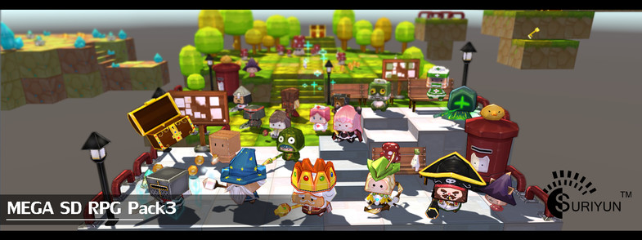

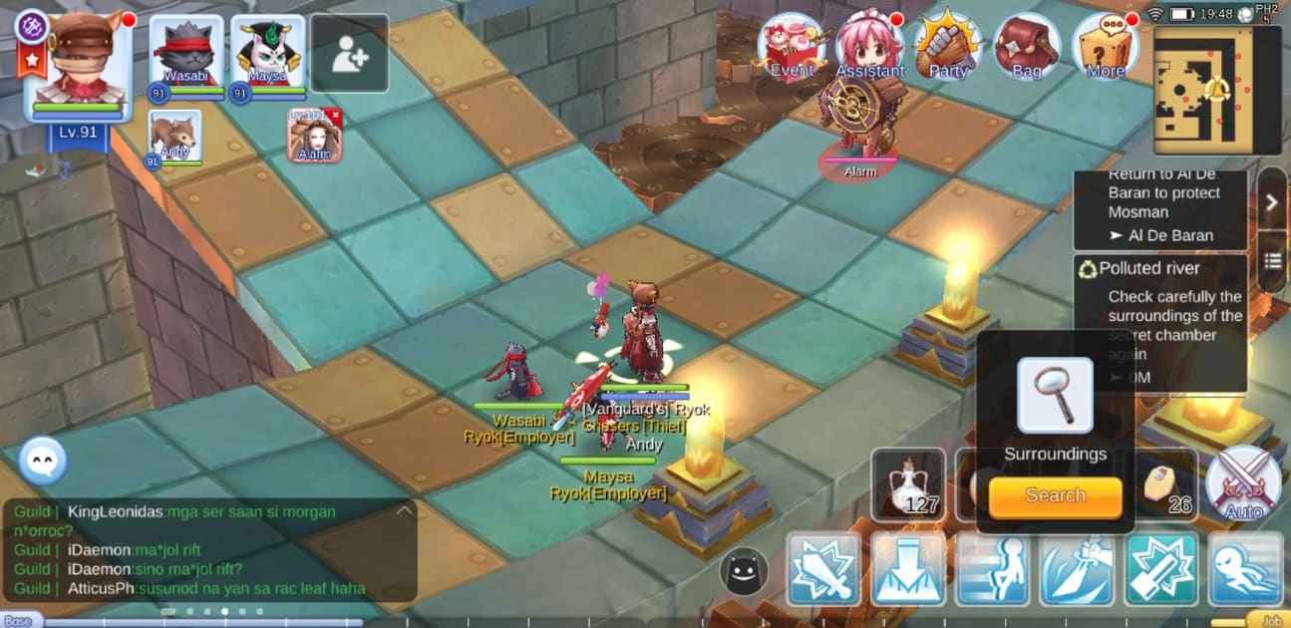

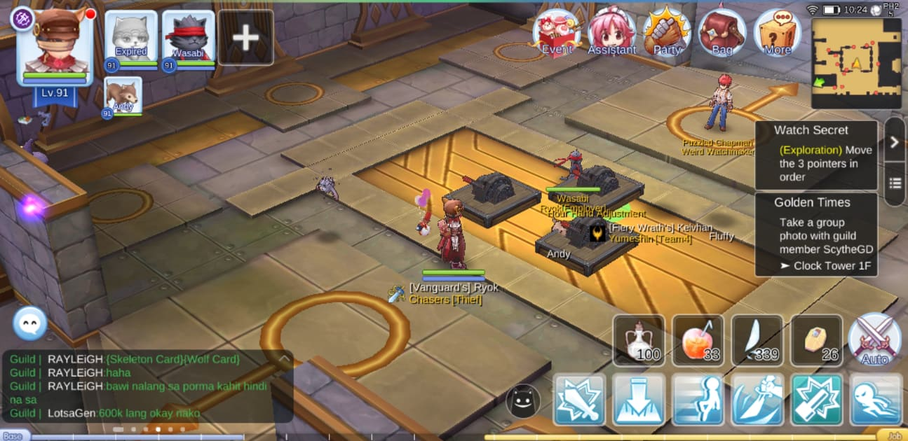

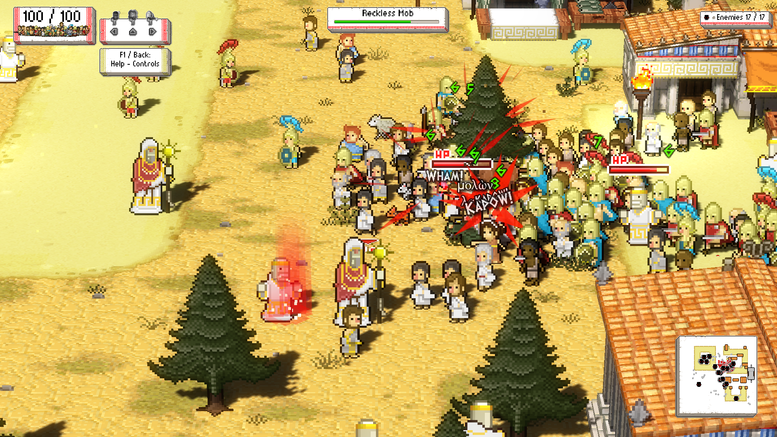

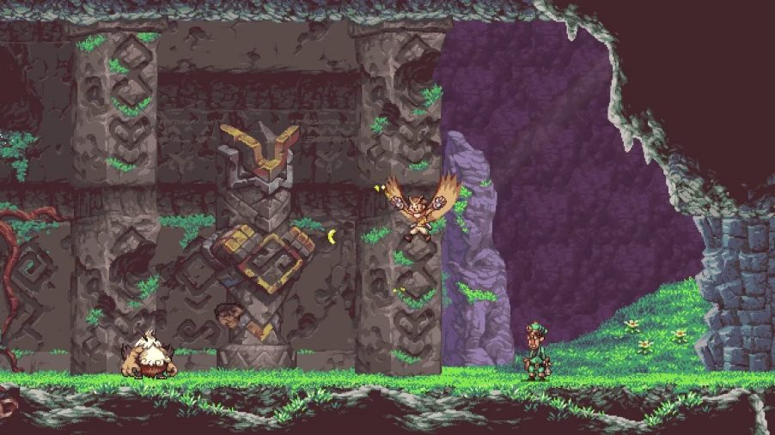

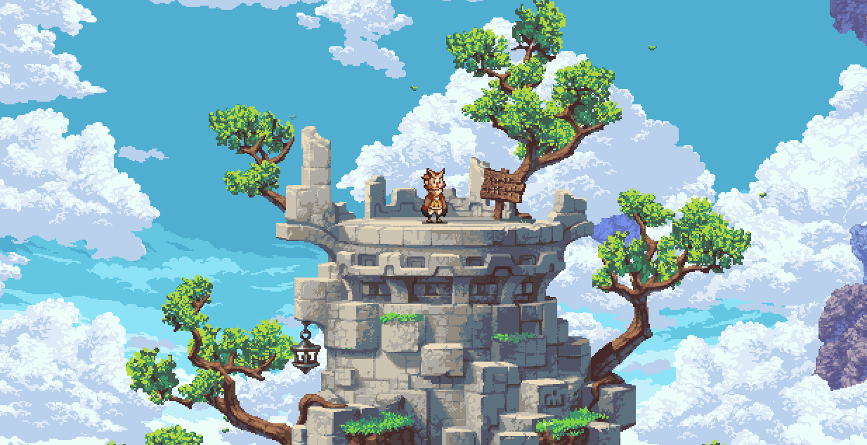

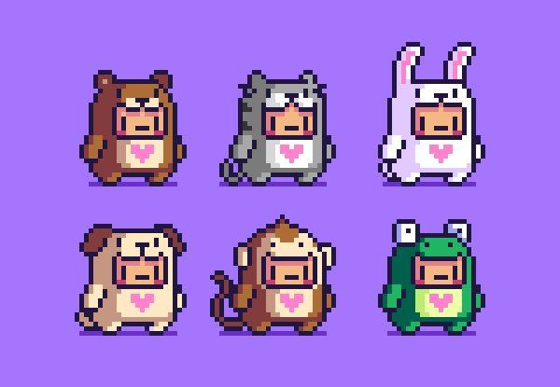

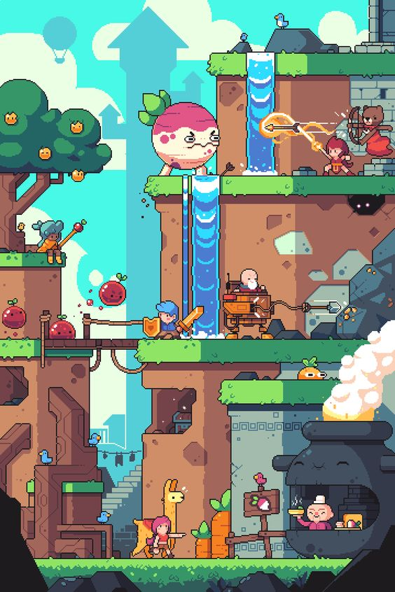

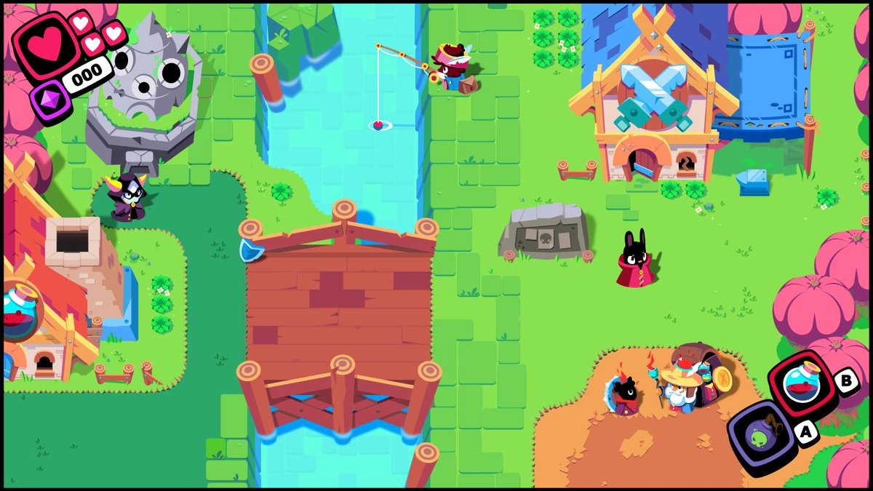

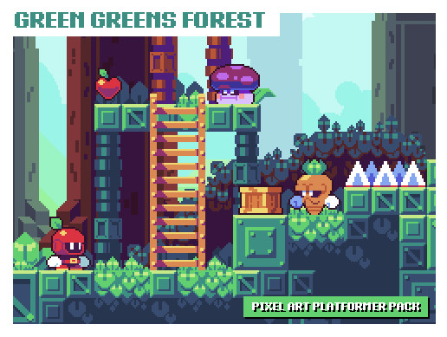

1. **Gameplay and Mechanics**
   1. **Gameplay**
      1. **Game Progression**

For now, there will be 4 level, and each is associate with the theme. (jungle, castle, land, lagoon). A level contains only a dungeon for now.

Tutorial

Jungle

Castle

Land

Lagoon

Ruin

Dungeons 1-4

Dungeons 1-4

Dungeons 1-4

Dungeons 1-4

* + 1. **Mission/challenge Structure**

1. Tutorial

Tutorial

In tutorial, we teach the players to understand the basic control of the game. From the general action, magic, possessing, and defending. We also give them mini challenge like scoring number of goals, stunning the opponents, and using in-game items.

The player will be introduced to the types of tile. For now the type of tiles and the items are still undefined yet.

We can make the challenge through: Item, tiles, skill, enemies, and difficulty, for each of the level.

1. Jungle
2. Castle
3. Land
4. Lagoon
5. Final Boss
   * 1. **Puzzle Structure**

Undefined.

* + 1. **Objectives**

The objectives of the game is pretty simple at general. The players need to win the football game before the time is over. Maybe through the levels the objectives (quests) are differed. It can be different in item use, tiles, skill, enemies, and difficulty.

Quest?

* 1. **Mechanics**
     1. **Character**

The character that the players can play. Each character may have special ability associated.

* + - 1. **General**

This is the basic action that any character can do.

* + - * 1. **Jump**

The player can jump as high as high tiles and over the character in order to defends, dribbles, and attacks, avoids the obstacles.

* + - * 1. **Move**

The player can move to 4 direction for now (8 direction later): left right, up, down. The player can’t passing through the wall or gap tiles except with jumping.

* + - * 1. **Shoot (Offense) || Tackle (Defense)**

When the player possesses the ball, he can shoot to the goal. But when the player is not possesses the ball, he can tackle or hit the opponent to damage, stun, or steal the ball.

* + - * 1. **Pass (Offense) || Follow (Defense)**

When the player possesses the ball, he can pass to the other player in the same team. The player can automatically follow the possessing opponent to steal the ball when play defense.

The offending player will have variable to indicate the damage he can block (or simply using the HP). The skill and action the offending player do have delay.

* + - 1. **Magic**

This is the magic skill that the character can do. For each tackle, pass, and shoot did by the players will increase their manna. The manna can also be get from the spawning item.

* + - * 1. **Light**

Light magic has less impact but more convenience to use (less requirement). For now, the skills are: increasing movespeed and flying for a short time, tackling with big damage.

* + - * 1. **Heavy**

Heavy magic has more impact to the scoring process i.e, powerfull shot or damaging action, direct stun, bubble guard.

Tutorial Main Menu

PosessionPosession

General General

MagicMagic

DefenseDefense

Mini challenge Mini challenge

* + 1. **Tiles**

The tiles in this game are vary in categories: damaging, moving, and mutating.

These are the tile types:

* + - 1. **Normal Tiles**

Just regular normal tiles.

* + - 1. **Spiky Tiles**

Spiky tiles may hurt the player in a little amount of damage.

* + - 1. **Exploding Tiles**

Exploding tiles will immediately stun the player.

* + - 1. **Mystery Box Tiles**

Tiles that have mystery box.

* + - 1. **Shooting Tiles**

The tiles that can rapidly shoots arrows in a certain direction.

The tiles may also have one of these characteristics:

* + - **None**

Has no characteristics.

* + - **Invisible**

Tiles that can be invisible for a limited time.

* + - **Rising up**

Tiles that will block the player or ball movement. The rising up tiles with high speed will fly the player to the sky.

* + 1. **Actions**

Already explained in 3.2.1 Character. The player can also pick an item, pass the effect of the item, scoring a goal.

* + 1. **Magic**

Already explained in 3.2.1 Character.

* + 1. **Mystery Box Items**

There will be positive and negative items.

* + - 1. **Bomb**

Damaging the taker for a certain of time if it is not passed to the opponent.

* + - 1. **Manna Potion**

Refresh the manna pool of a player.

* + - 1. **HP Potion**

Refresh the HP pool of a player.

* + - 1. **Speed Potion**

Increase the move speed of a player for a limited time.

* + 1. **Physics**

**This part is exclusively explain in technical document.**

* + 1. **Movement in the game**
       1. **Move when possessing (defending)**

The move speed of a player when possessing the ball is reduced for a certain value.

* + - 1. **Move when not possessing (offending)**

When the player move while not possessing the ball, the move speed of a player is working normally.

* + - 1. **Fly**

The player may fly and bring the ball up high avoiding the opponents and bad tiles. The player can fly by using an item or skill.

* + 1. **Other Objects**

Other objects that are important in the game.

* + - 1. **Match related**

All object that are related to the sport mechanics.

* + - * 1. **Out Throw Wall**

To prevent the ball out from the field. Because, in this game we don’t implement any throw in, corner kick, or any free kick.

* + - * 1. **Goals**

A goal for each team. Later on, a goal can be manipulated by player skill.

* + - * 1. **Field**

A helper lines just to make the field feels like a football field.

* + - 1. **Environment**

All object that are being the decorations of the game.

* + - * 1. **Tree**

The trees have seasonal look to match the season.

* + - * 1. **Cloud**

Just clouds.

* + - * 1. **Weather/ Season**

Already explained in previous chapter.

* + - * 1. **Supporter**

Imagine playing a magical football and being watched by my witches.

* + 1. **Interactions**
    2. **Player with player**
* The player can real communicate with their own team
* Can tackle their opponents or their own teammate
* Can pass to their own teammate
* The player can follow the opponent possessing the ball
  + 1. **Player with game**
* Player can follow the ball
* Can modify the tiles
* Take the mystery boxes
* Walking over, jumping over, or flying over the tiles
  + 1. **Combat**

The combat is simply emerge when the player use Tackle and Magic skills.

* + 1. **Melee**

The melee combat is done by performing the Tackle to the opponents.

* + 1. **Ranged**

The ranged combat, for now, is done by the magic ability.

* + 1. **Economy**

This is still undefined. May be there will be char history stats, in-game currency, item to purchase, and so on.

* + 1. **Screen Flow**

Already explained in 3.1.1 Gameplay Progression

* 1. **Game Options**

Undefined yet. For now, changing the language, quality of video, sound volume.

* 1. **Replaying and Saving**

The game is automatically saved after player play the game either it is a campaign or quick multiplayer.

* 1. **Cheats and Easter Eggs**

The player can use cheat in a very certain of dungeon then the player can use skills to modify the tiles and press some buttons combination.

1. **Story, Setting and Character** 
   1. **Story and Narrative** 
      1. **Back story Characters**

* **Boy (Ponari)**

A boy who wants some adventurous journey and ended up in a witch football game in the dungeons. His hair is either grey or light black.

* **Girl**

The boy’s crush that accidentally brought to the dungeon by the wish of the boy without knowing anything. Her hair is yellow.

* **Cat**

A white cute cat of the boy. She is smart and no one expect that she can talk in the end.

* **Hairy**

A famous wizard from the wizard world. There is a bolt symbol in his face. But one thing for sure, he is so hairy.

* **Dumbledore**

The greatest old wizard in this universe. He is so big and also strong. He appears in a blue wizard costume with a typical blue hat. He brings the fitness dumble everywhere he goes.

* **Red Riding Hood**

The famous character of the kids’ tale. She is searching the wolf who frightening her grandma. She is wearing a hoodie and talking like a homie.

* + 1. **Plot elements**

Not defined yet.

* + 1. **Game progression**

Not defined yet.

* + 1. **Cut scenes. Cut scenes descriptions include the actors, the setting, and the storyboard or script.**

As for now, the cutscene be seen when:

* + - 1. **Match Intro**

Just like Dota, there will be character intro before entering the match field as well as showing the players stats.

Intro

Intro CutsceneSo Called Adventure

STATS

STATS

VS

* + - 1. **Using Skill & Goal**

When the player using any skill, there will be anime-like cutscene moving in and out of the screen.

Intro

Skill Cutscene

* + - 1. **Post Match**

Similar to the match intro, showing the resulting match stats as well.

Intro

Post Match Cutscene

Win next time

WIN

* 1. **Game World**
     1. **General look and feel of world**
     2. **Areas, including the general description and physical characteristics as well as how it relates to the rest of the world (what levels use it, how it connects to other areas)**
  2. **Characters. Each character should include the back story, personality, appearance, animations, abilities, relevance to the story and relationship to other characters**

1. **Levels**
   1. **Levels. Each level should include a synopsis, the required introductory material (and how it is provided), the objectives, and the details of what happens in the level. Depending on the game, this may include the physical description of the map, the critical path that the player needs to take, and what encounters are important or incidental.**
   2. **Training Level**
2. **Interface**
   1. **Visual System** 
      1. **Match**

When the match is palying, there will be a timer, team label and score, and players HUD.

Match

Timer

Score

Score

* + 1. **Paused**

When the match is paused, the screen is blurred to highlight the resume command text.

Pause

Score

Score

**Press start to resume**

* + 1. **TextEffect**

There are some text effect: jittering, zoom, fade in and out, rotation, and color change.

* 1. **Control System**

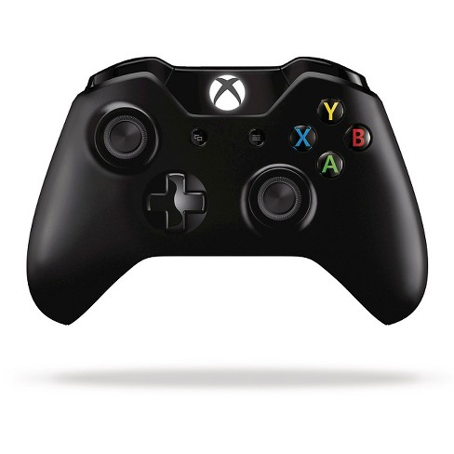

* + 1. **Menu**

Button A or B to accept, and Y to back or cancel.

* + 1. **Gameplay**
* DPad to move
* A to follow or pass
* X to tackle or shoot
* B to light skill
* Y to heavy skill
* RB to jump
* Start to pause or resume the game
  1. **Audio, music, sound effects**
     1. **BGM**
        1. **General Gameplay**
        2. **Spring**
        3. **Winter**
        4. **Autumn**
        5. **Summer**
     2. **SFX**
        1. **Witch**
* **Expression**
  + **Agree**
  + **Disagree**
  + **Surprise**
  + **Idle**
  + **Boring**
  + **Happy**
  + **Sad**
  + **Laugh**
  + **Cry**
  + **Screaming**
* **Activity** 
  + **Shoot**
  + **Pass**
  + **Tackle**
  + **Tackled**
  + **Intercept**
  + **Block**
  + **Stunned**
  + **Scoring**
  + **Falling**
* **Skills (Light and Heavy)**
  + **Damage (Rage)**
  + **Heal**
  + **Power**
  + **Speed (Boost)** 
    - 1. **Ball**
* **Dribble**
  + **Spring Grass**
  + **Autumn Leaf**
  + **Summer Ground**
  + **Winter Snow**
  + **Normal Plane**
* **Hit Goal & Pole**
* **Falling**
* **Kicked**
* **Controlled**
* **Rage**
  + - 1. **Skills**
* **Damage**
* **Heal**
* **Power**
* **Speed**
  + - 1. **Potions**
* **Damage**
* **Heal**
* **Power**
* **Speed**
  + - 1. **Environment**
* **Audience**
  + **Clap**
  + **Boo**
  + **Cheers**
  + **Laugh**
* **Tiles**
  + **Types**
    - **Falling Rock**
    - **Shooter**
    - **Spiky Slash**
    - **Explode**
  + **Effect** 
    - **Rise and Fall**
    - **Invisible**
  + **Trigger area sign**
    - 1. **Weather**
* **Rain**
* **Snow**
* **Storm**
* **Wind**
* **Night**
* **Ghostly**
  + - 1. **UI**
* **Start/ Pause (sucked in and out)**
* **Clicked**
* **Released**
* **Earthquake** 
  + 1. **Setting**

Not Defined

* 1. **Help System**

Not defined

1. **Artificial Intelligence**
   1. **Opponent and Enemy AI – The active opponent that plays against the game player and therefore requires strategic decision making**
   2. **Non-combat and Friendly Characters**
   3. **Support AI -- Player and Collision Detection, Pathfinding**
2. **Technical** 
   1. **Target Hardware**
   2. **Development hardware and software, including Game Engine**
   3. **Network requirements**
3. **Game Art – Key assets, how they are being developed. Intended style.**